

Republic of the Philippines
Province of Laguna
Municipality of Lumban
Office of the Sangguniang Bayan

EXCERPT FROM THE MINUTES OF THE REGULAR SESSION OF THE HON. SANGGUNIANG BAYAN OF LUMBAN, LAGUNA HELD ON FEBRUARY 22, 2022 AT ATTY. BENJAMIN E. AGARAO SR. MEMORIAL HALL AT EXACTLY 10:13 IN THE MORNING.

PRESENT:
HON. BELEN B. RAGA ---------------- Vice Mayor/ Presiding Officer
HON. ROSE ANN R. AÑONUEVO ---------------- SB Member
HON. IRENEO R. BALDOVINO ---------------- SB Member
HON. GERONIMO P. SAMONTE JR. ---------------- SB Member
HON. SHERYLL TABLICO-GAURINO ---------------- SB Member
HON. ORLANDO R. DE LUNA ---------------- SB Member
HON. JOHN ALBERT RANA --------------- SB Member
HON. ARIEL D. AÑONUEVO ---------------- President-LNB
HON. DONNIE L. DE VENECIA ---------------- President-SKF

ABSENT:
HON. RHODA DM. RABIE ---------------- SB Member
HON. EDGARDO B. GONZALES ---------------- SB Member

RESOLUTION NO. 05 S. 2022

A RESOLUTION AUTHORIZING THE HONORABLE MAYOR ROLANDO G. UBATAY TO ENTER AND SIGN FOR AND ON BEHALF OF THE MUNICIPAL GOVERNMENT OF LUMBAN INTO A MEMORANDUM OF AGREEMENT (MOA) WITH THE PHILIPPINE AMUSEMENT AND GAMING CORPORATION (PAGCOR) REGARDING THE CONSTRUCTION OF A FIFTY MILLION PESOS (P50,000,000.00) WORTH OF SLOPE PROTECTION PROJECT IN BARANGAY BALUBAD

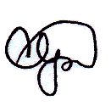
Authored by HON. GERONIMO P. SAMONTE JR.
Committee Chairman on Public Works,
Transportation and Communication

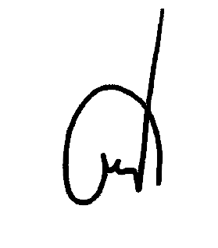
WHEREAS, the Municipal Government of Lumban has previously communicated its earnest desire to the Philippine Amusement and Gaming Corporation through Kapasiyahan Blg. 75(A) T. 2021 entitled, “KAPASIYAHANG MAPITAGANG HUMIHILING KAY KGG. ANDREA DIZON DOMINGO, CHAIRPERSON AND CHIEF EXECUTIVE OFFICE (CEO) NG PHILIPPINE AMUSEMENT AND GAMING CORPORATION (PAGCOR) NA MAPAGKALOOBAN NG TULONG PINANSIYAL NA NAGKAKAHALAGA NG LIMAMPUNG MILYONG PISO (P5,000,000.00) ANG PAMAHALAANG BAYAN NG LUMBAN UPANG ILAAN SA PAGPAPAGAWA NG SLOPE PROTECTION NG LUMBAN RIVER SA BARANGAY BALUBAD”, to be a beneficiary of PAGCOR’s financial assistance program aimed to help communities in the rural areas in order to make them resilient and prepared when calamities strike, and also to reduction of possible adverse effect of natural disaster like flood, through the construction of risk reduction infrastructure like the slope protection wall;


WHEREAS, due to financial constraint, PAGCOR throughout its existence became the partner of the national and local government units in the implementation of significant projects concerning education, health and medication, community development, disaster preparedness, relief operations, livelihood, sports development and other infrastructure projects;

WHEREAS, the river control or the slope protection was tested as an effective flood control project that could protect the people from possible serious threat brought by swelling of the river and continuous soil erosion, and life-saving barrier for the protection of thousands of residents of the most flood prone areas in the municipality;

WHEREAS, due to limited budget allocation for infrastructure projects, the Local Government of Lumban is very much in need of financial assistance for the execution of priority thrusts that would maximize positive effects on the local socio-economic progress;

WHEREAS, in spite of the development and progress experienced in the past years, the Municipal Government of Lumban continuously operates on the budget where most were supplied by the share from the Internal Revenue Allotment (IRA), thus, it is experiencing a huge insufficiency in funds needed for the implementation of priority programs and projects;

WHEREAS, the Municipal Government’s noble objective will only be fulfilled by assistance and support of agencies like PAGCOR through its Chairperson and Chief Executive Officer (CEO) Hon. Andrea Dizon Domingo;

NOW THEREFORE, on the motion of Hon. Geronimo P. Samonte Jr., duly seconded by Hon. Orlando R. De Luna, and with the concurrence of all members present it was;

RESOLVED, as it is hereby RESOLVED to authorize the Honorable Mayor Rolando G. Ubatay to enter and sign for and on behalf of the Municipal Government of Lumban into a Memorandum of Agreement (MOA) with the Philippine Amusement and Gaming Corporation (PAGCOR) regarding the construction of a Fifty Million Pesos (P50,000,000.00) worth of slope protection project in Barangay Balubad;

RESOLVED FURTHER, to transmit copy of this resolution to the PAGCOR Executive Office at 5th floor New Coast Hotel Manila, 1588 MH Del Pilar corner Pedro Gil Streets, Malate, Manila, Philippines 1004, and other concern offices for their information and appropriate action

APPROVED this 22nd day of February, 2022.

I HEREBY CERTIFY as to the correctness of the above quoted resolution.

.

CORAZON B. PADUA
Sangguniang Bayan Secretary

ATTESTED:

BELEN B. RAGA
Municipal Vice Mayor/Presiding Officer

APPROVED:
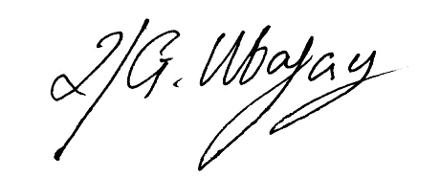

ROLANDO G. UBATAY
Xcerpt022222res05
Municipal Mayor

