

Republic of the Philippines
Province of Laguna
Municipality of Lumban
Office of the Sangguniang Bayan

EXCERPT FROM THE MINUTES OF THE REGULAR SESSION OF THE HON. SANGGUNIANG BAYAN OF LUMBAN, LAGUNA HELD ON DECEMBER 16, 2020 AT ATTY. BENJAMIN E. AGARAO SR. MEMORIAL HALL AT EXACTLY 11:17 IN THE MORNING.

PRESENT:
HON. BELEN B. RAGA ---------------- Vice Mayor/ Presiding Officer
HON. RHODA DM. RABIE ---------------- SB Member
HON. ROSE ANN R. AÑONUEVO ---------------- SB Member
HON. IRENEO R. BALDOVINO ---------------- SB Member
HON. GERONIMO P. SAMONTE JR. ---------------- SB Member
HON. SHERYLL TABLICO-GAURINO ---------------- SB Member
HON. ORLANDO R. DE LUNA ---------------- SB Member
HON. JOHN ALBERT C. RANA ---------------- SB Member
HON. EDGARDO B. GONZALES ---------------- SB Member
HON. ARIEL D. AÑONUEVO ---------------- President-LNB
HON. RENZO L. MATIENZO ---------------- President-SKF

RESOLUTION NO. 116 S. 2020

A RESOLUTION HUMBLY REQUESTING THE DEPARTMENT OF PUBLIC WORKS AND HIGHWAYS (DPWH) THROUGH DISTRICT ENGINEER CORAZON V. CABATBAT TO ALLOCATE FUND FOR THE CONSTRUCTION OF BRIDGE AT BARANGAY WAWA LUMBAN, LAGUNA.

Authored by Hon. Geronimo P. Samonte Jr.

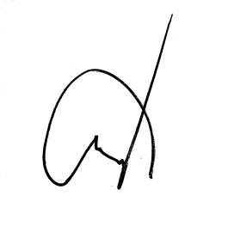
WHEREAS, the Department of Public Works and Highways is responsible for the planning design construction and maintenance of infrastructure especially the national highways flood control and water resources development system and other public works;

WHEREAS, the town of Lumban was granted financial assistance intended for the construction of bridge at Barangay Wawa Lumban, Laguna;

WHEREAS, relative to the construction of Bridge at Wawa-Culion, the municipal Officials of Lumban, Laguna is humbly requesting the DPWH to prepare the planning design and program of works of the above-mentioned project;

NOW THEREFORE, on motion of Hon. Geronimo P. Samonte Jr. duly seconded by Hon. Orlando R. De Luna and with the concurrence of all Members present, it was;

RESOLVED, as it is HEREBY RESOLVED by the Sangguniang Bayan of Lumban, Laguna by virtue of the powers vested in it by law, in session assembled, to pass and approve the a resolution humbly requesting the Department of Public Works and Highways (DPWH) through District Engineer Corazon V. Cabatbat to allocate fund for the construction of bridge at Barangay Wawa Lumban, Laguna.

RESOLVED FURTHER, that copy of this resolution be furnished the office of District Engineer Corazon V. Cabatbat and all offices concerned for their information, guidance and reference.

APPROVED, this 16th Day of December, 2020.

I HEREBY CERTIFY to the correctness of the above-quoted resolution.

CORAZON B. PADUA
Sangguniang Bayan Secretary

ATTESTED:

BELEN B. RAGA
Municipal Vice Mayor /Presiding Officer

APPROVED:
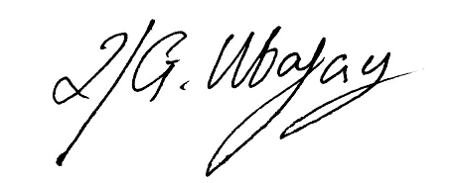

ROLANDO G. UBATAY
Municipal Mayor

Xcrpt121620res116

