

Republic of the Philippines
Province of Laguna
Municipality of Lumban
Office of the Sangguniang Bayan

EXCERPT FROM THE MINUTES OF THE REGULAR SESSION OF THE HON. SANGGUNIANG BAYAN OF LUMBAN, LAGUNA HELD ON AUGUST 01, 2022 AT ATTY. BENJAMIN E. AGARAO SR. MEMORIAL HALL AT EXACTLY 09:48 IN THE MORNING.

PRESENT:
HON. BELEN B. RAGA ---------------- Vice Mayor/ Presiding Officer
HON. MA. ROMA R. TABLICO ---------------- SB Member
HON. MODESTO B. ABADIER ---------------- SB Member
HON. MARK ANTHONY L. LAGROSA ---------------- SB Member
HON. IRENEO R. BALDOVINO ---------------- SB Member
HON. ROSE ANN R. AÑONUEVO ---------------- SB Member
HON. JOHN DEMBER A. DELOS REYES ---------------- SB Member
HON. ATTY. JEROMME R. LACBAY ---------------- SB Member
HON. GERONIMO P. SAMONTE JR. ---------------- SB Member
HON. ARIEL D. AÑONUEVO ---------------- President-LNB
HON. DONNIE L. DE VENECIA ---------------- President-SKF

RESOLUTION NO. 39 s. 2022
A RESOLUTION HUMBLY REQUESTING THE GENEROUS REPRESENTATIVE OF 4TH DISTRICT OF LAGUNA HON. MARIA JAMINA KATHERINE B. AGARAO FOR FINANCIAL ASSISTANCE TO BE ALLOTTED FOR THE CONSTRUCTION OF THE NEW MUNICIPAL CEMETERY OF LUMBAN

Authored by HON. GERONIMO P. SAMONTE JR.
Chairperson, Committee on Public Works, Transportation and Communication

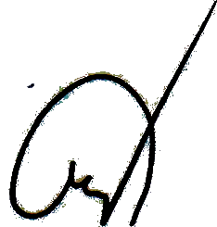
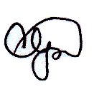
WHEREAS, Section 16 of RA 7160 otherwise known as the “Local Government Code of 1991” states “Every local government unit shall exercise the powers expressly granted, those necessarily implied therefrom, as well as powers necessary, appropriate, or incidental for its efficient and effective governance, and those which are essential to the promotion of the general welfare. Within their respective territorial jurisdictions, local government units shall ensure and support, among other things, the preservation and enrichment of culture, promote health and safety, enhance the right of the people to a balanced ecology, encourage and support the development of appropriate and self-reliant scientific and technological capabilities, improve public morals, enhance economic prosperity and social justice, promote full employment among their residents, maintain peace and order, and preserve the comfort and convenience of their inhabitants.”;

WHEREAS, Article II, Section 447 of the Act mandates the Sangguniang Bayan of Lumban to promote the general welfare of the inhabitants of the Municipality through the enactment of local ordinances and resolutions;

WHEREAS, the Municipal Government in view of the foregoing provisions, approved its plan to construct a new Municipal Cemetery for the old burial ground is already congested and the need for a decent and hygienic resting place for the departed Lumbeños must be provided;

WHEREAS, due to scarcity of resources the Municipal Government found out that it is challenging to finance such a massive project, so there is a need to ask from higher LGU for assistance in order to realized the plan;


WHEREAS, it is essential to bring around the spirit of bayanihan amongst the key personalities and leaders of the Province in order to provide and operate a new public cemetery to address the clamor of the constituents for a decent and affordable final resting place for their dearly departed;
NOW THEREFORE, on the motion of Hon. Geronimo P. Samonte Jr., duly seconded by Hon. Modesto B. Abadier, Hon. Mark Anthony L. Lagrosa, Hon. Rose Ann R. Añonuevo and unanimously approved by all members present it was;

RESOLVED, as it is HEREBY RESOLVED, to humbly request the generous Representative of 4th District of Laguna Hon. Maria Jamina Katherine B. Agarao for financial assistance to be allotted for the construction of the new Municipal Cemetery of Lumban;

RESOLVED FURTHER, to furnish copy of this Resolution to the Hon. Maria Jamina Katherine B. Agarao and other concern offices for their knowledge and appropriate measure.

APPROVED, this 1st day of August, 2022.

I HEREBY CERTIFY as to the correctness of the foregoing resolution.

CORAZON B. PADUA
SB Secretary

ATTESTED:

BELEN B. RAGA
Municipal Vice Mayor /Presiding Officer

APPROVED:

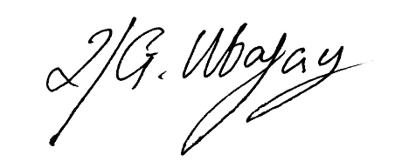

ROLANDO G. UBATAY
Municipal Mayor Xcerpt080122res39

