

Republic of the Philippines
Province of Laguna
Municipality of Lumban
Office of the Sangguniang Bayan

EXCERPT FROM THE MINUTES OF THE REGULAR SESSION OF THE HON. SANGGUNIANG BAYAN OF LUMBAN, LAGUNA HELD ON AUGUST 01, 2022 AT ATTY. BENJAMIN E. AGARAO SR. MEMORIAL HALL AT EXACTLY 09:48 IN THE MORNING.

PRESENT:
HON. BELEN B. RAGA ---------------- Vice Mayor/ Presiding Officer
HON. MA. ROMA R. TABLICO ---------------- SB Member
HON. MODESTO B. ABADIER ---------------- SB Member
HON. MARK ANTHONY L. LAGROSA ---------------- SB Member
HON. IRENEO R. BALDOVINO ---------------- SB Member
HON. ROSE ANN R. AÑONUEVO ---------------- SB Member
HON. JOHN DEMBER A. DELOS REYES ---------------- SB Member
HON. ATTY. JEROMME R. LACBAY ---------------- SB Member
HON. GERONIMO P. SAMONTE JR. ---------------- SB Member
HON. ARIEL D. AÑONUEVO ---------------- President-LNB
HON. DONNIE L. DE VENECIA ---------------- President-SKF

RESOLUTION NO. 43 S. 2022

A RESOLUTION HUMBLY REQUESTING THE HON. SENATOR ROBINHOOD FERDINAND “ROBIN” CARIÑO PADILLA FOR FINANCIAL ASSISTANCE TO FINANCE THE CONSTRUCTION OF THE SECOND FLOOR OF THE OLD OFFICE BUILDING CURRENTLY OCCUPIED BY THE COMMELEC, BIR AND PHIL POST, SITUATED AT THE SIDE PORTION OF LUMBAN TOWN PLAZA

Authored by: Hon. Ireneo R. Baldovino

WHEREAS, Article II, Section 447 of R.A. 7160 otherwise known as the “Local Government Code of 1991”, mandates the Sangguniang Bayan of Lumban to promote the general welfare of the inhabitants of the Municipality through the enactment of local ordinances and resolutions;

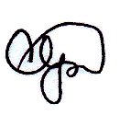
WHEREAS, personnel working in the field office of the COMMELEC, the BIR and Phil. Post find it difficult to work in their respective post due to congestion and limited space to store in the effects and documents filed in the office;

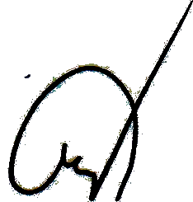
WHEREAS, the mentioned national offices are housed in a converted old school building located at the side portion of Lumban Town Plaza;

WHEREAS, the financial assistance to be provided by the office of the generous Hon. Senator for the purpose, will surely benefit the field office of the COMMELEC, BIR and Phil Post as well as other national field office in the municipal hall who are experiencing congestions and space shortage that in the long run will provide comfortable and convenient place for the employees to work in;

THEREFORE, on motion of Hon. Ireneo R. Baldovino duly seconded by Hon. Geronimo P. Samonte Jr. unanimously approved by all Members present, it was;

RESOLVED as it is hereby RESOLVED to humbly request the Hon. Senator Robinhood Ferdinand “Robin” Cariño Padilla for financial assistance to finance the construction of the second floor of the old office building currently occupied by the COMMELEC, BIR and PHIL POST, situated at the side portion of Lumban Town Plaza.

RESOLVED FURTHER, to transmit copy of this resolution to the Office of the Hon. Robinhood Ferdinand “Robin” Cariño Padilla for his information and appropriate action.

APPROVED, this 01st day of August, 2022.

I HEREBY CERTIFY as to the correctness of the foregoing resolution.

CORAZON B. PADUA
SB Secretary

ATTESTED:

BELEN B. RAGA
Municipal Vice Mayor /Presiding Officer

APPROVED:

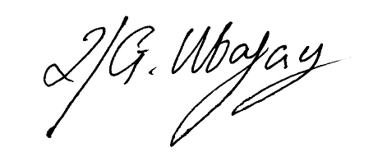

ROLANDO G. UBATAY
Municipal Mayor Xcerpt080122res43

