

Republic of the Philippines
Province of Laguna
Municipality of Lumban
Office of the Sangguniang Bayan

EXCERPT FROM THE MINUTES OF THE REGULAR SESSION OF THE HON. SANGGUNIANG BAYAN OF LUMBAN, LAGUNA HELD ON NOVEMBER 28, 2022 AT ATTY. BENJAMIN E. AGARAO SR. MEMORIAL HALL AT EXACTLY 09:26 IN THE MORNING.

PRESENT:
HON. BELEN B. RAGA ---------------- Vice Mayor/ Presiding Officer
HON. MA. ROMA R. TABLICO ---------------- SB Member
HON. MODESTO B. ABADIER ---------------- SB Member
HON. MARK ANTHONY L. LAGROSA ---------------- SB Member
HON. IRENEO R. BALDOVINO ---------------- SB Member
HON. ROSE ANN R. AÑONUEVO ---------------- SB Member
HON. JOHN DEMBER A. DELOS REYES ---------------- SB Member
HON. ATTY. JEROMME D. LACBAY ---------------- SB Member
HON. GERONIMO P. SAMONTE JR. ---------------- SB Member
HON. ARIEL D. AÑONUEVO ---------------- President-LNB
HON. DONNIE L. DE VENECIA ---------------- President-SKF

RESOLUTION NO. 99 S. 2022

A RESOLUTION HUMBLY REQUESTING HON. BENJAMIN S. ABALOS SR., MAYOR OF THE SISTER-CITY OF MANDALUYONG, FOR FINANCIAL ASSISTANCE AMOUNTING TO TEN MILLION PESOS (P 10,000,000.00) TO BE ALLOTTED FOR THE CONSTRUCTION OF PHASE II OF THE NEW MUNICIPAL CEMETERY OF LUMBAN

Authored by HON. GERONIMO P. SAMONTE JR.
Chairperson, Committee on Public Works, Transportation and Communication

WHEREAS, Section 16 of RA 7160 otherwise known as the “Local Government Code of 1991” states “Every local government unit shall exercise the powers expressly granted, those necessarily implied there from, as well as powers necessary, appropriate, or incidental for its efficient and effective governance, and those which are essential to the promotion of the general welfare. Within their respective territorial jurisdictions, local government units shall ensure and support, among other things, the preservation and enrichment of culture, promote health and safety, enhance the right of the people to a balanced ecology, encourage and support the development of appropriate and self-reliant scientific and technological capabilities, improve public morals, enhance economic prosperity and social justice, promote full employment among their residents, maintain peace and order, and preserve the comfort and convenience of their inhabitants.”;

WHEREAS, Article II, Section 447 of the Act mandates the Sangguniang Bayan of Lumban to promote the general welfare of the inhabitants of the Municipality through the enactment of local ordinances and resolutions;

WHEREAS, the Municipal Government in view of the foregoing provisions, approved its plan to construct a new Municipal Cemetery for the old burial ground is already congested and the need for a decent and hygienic resting place for the departed Lumbeños must be provided;

WHEREAS, the Municipality of Lumban as one of Local Government Units (LGUs) in the countryside was urged to grab the opportunity and forged a twinning partnerships with the City of Mandaluyong and therefore regarded the City as an LGU partner and counterpart so as to promote goodwill and understanding, as well as other socio-cultural and economic aspects and development among the two LGUs;

WHEREAS, due to scarcity of resources it is challenging for a fourth class municipality like Lumban to finance such massive project, so there is a need to solicit assistance from partner LGUs to realize the project;

NOW THEREFORE, on the motion of Hon. Geronimo P. Samonte Jr., duly seconded by Hon. Mark Anthony L. Lagrosa, Hon. Modesto B. Abadier, Hon. Ma. Roma R. Tablico and unanimously approved by all members present it was;

RESOLVED, as it is HEREBY RESOLVED, to humbly request Hon. Benjamin S. Abalos Sr., Mayor of the Sister-City of Mandaluyong, for financial assistance amounting to ten million pesos (P 10,000,000.00) to be allotted for the construction of Phase II of the new Municipal Cemetery of Lumban;

RESOLVED FURTHER, to furnish copy of this Resolution the City Mayor of Mandaluyong, Hon. Benjamin S. Abalos Sr. and other concern offices for their knowledge and appropriate measure.

APPROVED, this 28th day of November, 2022.

I HEREBY CERTIFY as to the correctness of the foregoing resolution.

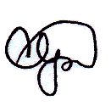

CORAZON B. PADUA Sangguniang Bayan Secretary
ATTESTED:
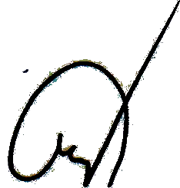

BELEN B. RAGA
Municipal Vice Mayor /Presiding Officer

APPROVED:

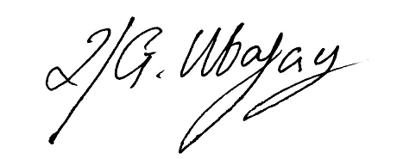

ROLANDO G. UBATAY
Municipal Mayor Xcerpt112822res99

