

Republic of the Philippines
Province of Laguna
Municipality of Lumban
Office of the Sangguniang Bayan

EXCERPT FROM THE MINUTES OF THE REGULAR SESSION OF THE HON. SANGGUNIANG BAYAN OF LUMBAN, LAGUNA HELD ON OCTOBER 16, 2017 AT ATTY. BENJAMIN E. AGARAO SR. MEMORIAL HALL AT EXACTLY 10:18 IN THE MORNING.

PRESENT:
HON. BELEN B. RAGA ----------------Vice Mayor/ Presiding Officer
HON. JOHNDELL A. SAMONTE ---------------- SB Member
HON. RHODA DM. RABIE ---------------- SB Member
HON. MARIA AURELIA E. QUIJANO ---------------- SB Member
HON. ROMELIO E. LADUB ---------------- SB Member
HON. SHERYLL G. TABLICO-GAURINO ---------------- SB Member
HON. IRENEO R. BALDOVINO ---------------- SB Member
HON. PEDRO S. ABE ---------------- SB Member
HON. JOHN ALBERT C. RANA ---------------- SB Member
HON. RUBEN R. DELOS REYES Sr. ---------------- President-LNB

RESOLUTION NO. 79 sERIES OF 2017

rESOLUTION HUMBLY REQUESTING THE HON. MAYOR ROLANDO G. UBATAY TO include IN THE ANNUAL APPROPRIATION THE 12% government share OF CASUAL EMPLOYEES to the gsis AND DIRECT THE MUNICIPAL ACCOUNTANT TO DEDUCT from thEIR WAGES the 9% PERSONAL SHARE.

AUTHOR: HON. BELEN B. RAGA
SPONSORED BY HON. MARIA AURELIA ELBO-QUIJANO.

WHEREAS, Section 3 of Republic Act No. 8291 “An Act Amending Presidential Decree No. 1146, as amended, expanding and increasing the coverage and benefits of the Government Service Insurance System, instituting reforms therein and for other purposes” states that “ Membership in the GSIS shall be compulsory for all employees receiving compensation who have not reached the compulsory retirement age, irrespective of employment status, except for the members of the Armed Forces of the Philippines and the National Police , and the contractual who have no employee-employer relationship;
WHEREAS, Section 5 (b) of the said Act states that “ The employer shall include in its annual appropriation the necessary amounts for its share of the contributions plus any premiums that maybe required on accounts of the hazards and risk of its employees occupation;
WHEREAS, the welfare of the casual employees is the utmost concern of the municipal officials wanting only that upon retirement, casuals could also avail of the same benefits accorded to regular employees.
THEREFORE, on motion of Hon. Maria Aurelia Elbo-Quijano duly seconded by Hon. Romelio E. Ladub and unanimously approved by all SB members present, it was;
RESOLVED, AS IT IS HEREBY RESOLVED TO HUMBLY REQUEST THE HON. MAYOR ROLANDO G. UBATAY TO include IN THE ANNUAL APPROPRIATION THE 12% government share OF CASUAL EMPLOYEES to the gsis AND DIRECT THE MUNICIPAL ACCOUNTANT TO DEDUCT from thEIR WAGES the 9% PERSONAL SHARE.

RESOLVED FURTHER, to transmit copies of this resolution to the Office of the Mayor for their information and approval.
APPROVED , this 16th day of October, 2017
I HEREBY CERTIFY as to the correctness and validity of the above-quoted resolution.


CORAZON B. PADUA
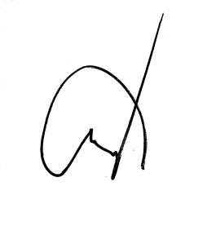
Sangguniang Bayan Secretary

ATTESTED:

BELEN B. RAGA
Municipal Vice Mayor /Presiding Officer

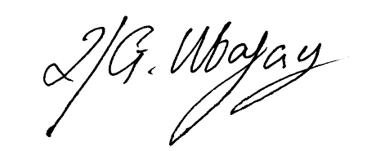
APPROVED:

ROLANDO G. UBATAY
Municipal Mayor

Xcerpt101617res79

