

Republic of the Philippines
Province of Laguna
Municipality of Lumban
Office of the Sangguniang Bayan

EXCERPT FROM THE MINUTES OF THE REGULAR SESSION OF THE HON. SANGGUNIANG BAYAN OF LUMBAN, LAGUNA HELD ON NOVEMBER 6, 2017 AT ATTY. BENJAMIN E. AGARAO SR. MEMORIAL HALL AT EXACTLY 9:23 IN THE MORNING.

PRESENT:
HON. BELEN B. RAGA ---------------- Vice Mayor/ Presiding Officer
HON. JOHNDELL A. SAMONTE ---------------- SB Member
HON. RHODA DM. RABIE ---------------- SB Member
HON. MARIA AURELIA E. QUIJANO ---------------- SB Member
HON. ROMELIO E. LADUB ---------------- SB Member
HON. SHERYLL G. TABLICO-GAURINO ---------------- SB Member
HON. IRENEO R. BALDOVINO ---------------- SB Member
HON. PEDRO S. ABE ---------------- SB Member
HON. JOHN ALBERT C. RANA ---------------- SB Member
HON. RUBEN R. DELOS REYES Sr. ---------------- President-LnB

RESOLUTION NO. 83 SERIES OF 2017

A RESOLUTION REQUESTING THE REGIONAL EXECUTIVE DIRECTOR OF THE DEPARTMENT OF AGRICULTURE, DIRECTOR ARNEL V. DE MESA TO GRANT THE MUNICIPAL GOVERNMENT OF LUMBAN, LAGUNA A UNIT OF RICE HARVESTER MACHINE TO BE UTILIZED BY THE FARMERS DURING HARVEST SEASONS.

Author: HON. IRENEO R. BALDOVINO

WHEREAS, the farmers, in their noblest effort of providing food for the Filipino people must be granted assistance from the cultivation to the harvest of rice to minimize the cost requirement of crop production and to increase profit as mean of empowering the farmers to become more productive and reliant to pursue crop cultivation for the succeeding season without ever resorting to high interest loans and unjust lending terms;

WHEREAS, the farmers of Lumban in the previous harvest season have tried to rent Rice Harvester Machines from the neighboring town, that in turn reduced their harvest labor cost by 40%, which means additional profit for the farmers;

WHEREAS, the Department of Agriculture as the main partner of the Local Government Units has developed programs to uplift the lives of the farmers by increasing crops production thru farm inputs, technical and other form of assistance;

WHEREAS, the Department thru its Regional Offices is capable of providing assistance such as the granting of farm inputs like the Rice Harvester Machine to the farmers of CALABARZON;

NOW THEREFORE, on the motion of Hon. Ireneo R. Baldovino duly seconded by, Hon. Rhoda DM Rabie, Hon. Romelio E. Ladub and Hon. Pedro S. Abe and with the concurrence of all members present, it was,

RESOLVED, as it is hereby resolved, to approve the Resolution requesting the Regional Executive Director of the Department of Agriculture, Director Arnel V. de Mesa to grant the Municipal Government of Lumban, Laguna a unit of Rice Harvester Machine to be utilized by the farmers during harvest season;

RESOLVED FURTHER, that copy of this Resolution shall be furnished the Regional Executive Director of the Department of Agriculture, Director Arnel V. de Mesa and all other concerned for their basis of information and guidance.

APPROVED this 6th of November, 2017.

I HEREBY CERTIFY to the correctness of the above-quoted resolution


CORAZON B. PADUA
Sangguniang Bayan Secretary

ATTESTED:


BELEN B. RAGA
Municipal Vice Mayor /Presiding Officer

APPROVED:
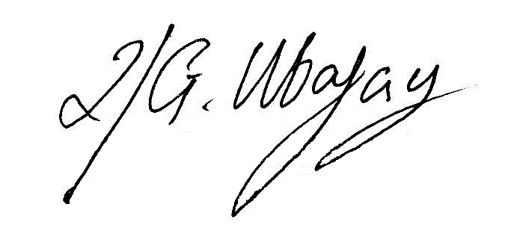

ROLANDO G. UBATAY
Municipal Mayor

Xcerpt110617res83

